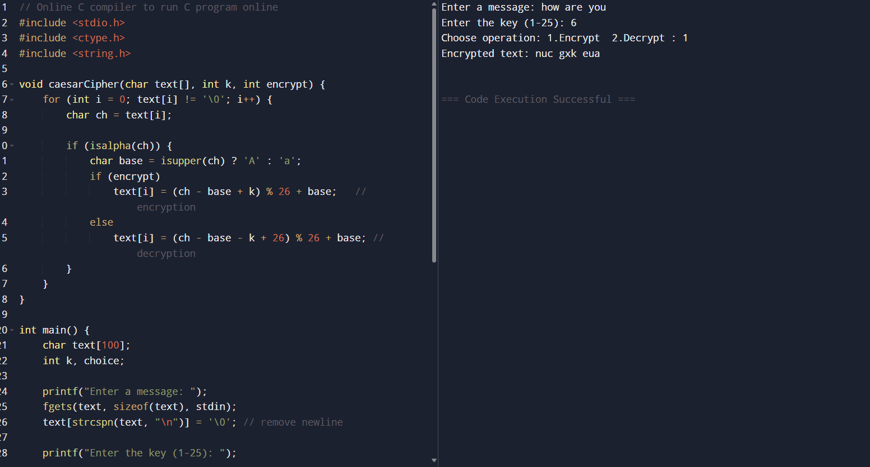 1.Write a C program for Caesar cipher involves replacing each letter of the alphabet with the letter standing k places further down the alphabet, for k in the range 1 through 25.

